Chronicles of the Bride - Heaven's Library & Tapestry of Life, Part 2
April 11th, 2022

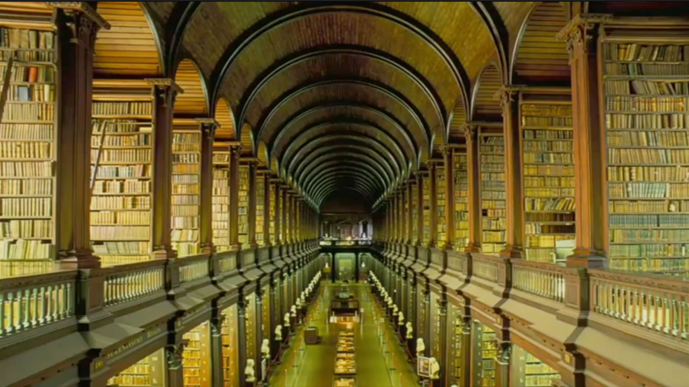
I hugged all three of them tightly as Christopher jumped up again and said, “We have something else to show you”. They now excitedly pulled me closer to the edge of the river and a beautiful gigantic swan appeared. It was so kind, and gentle as it bowed, to say hello. Christopher excitedly said, “Jump on!” I was startled but all the children hopped on the swan, and I excitedly followed as I was the last to get on.

The swan fluttered its huge wings arching them perfectly to its side so as to protect us from falling into the river. We began to steadily go down the river and all manner of fishes appeared, rainbow-colored, silver, jumping out of the river and over our heads to bring us laughter. Some stood up in the water on their fins and splashed away to give us a show. We laughed and waved at the fish as we went by. Then we went under a bridge and a tunnel and ended at the river bank. We hopped off the swan saying thank you as it continued on down the river. I then noticed a golden door with an angel guarding it right before us. I thought, “A door in the middle of the garden?” and Christopher, knowing my thoughts said, “If you believe it you can see it”. As the children giggled and the angel greeted us and opened the door, the children waved at the angel with familiarity.

When we stepped through the door we were in a library with golden floors. This library was huge—several feet high, with beautiful stairwells, some winding and some straight. I realized I was in the library of Heaven. Christopher, knowing my thoughts said, “There is more than one library in heaven, but this is the main library in Heaven”. I walked around turning and turning in awe at what I was seeing. I always thought to myself that all the personal journal entries that we have ever written on earth would be stored in heaven somewhere for all to read because nothing is private in heaven.

I had a sense that I was right, that our personal journals and notebooks were all here for people to read to know about our lives and stories. I then touched one of the books. As soon as I touched it I was infused with all the contents in the book immediately in my mind. It’s like reading a book in 30 seconds. I was amazed, and I thought to myself, “That makes sense, I will just touch the books instead of reading them”. There had to be over a million books here and Who would have the time to read that?

Once again, the children hearing my thoughts laughed and Christopher said, “What’s the fun in that? you have all eternity to read these books. I burst out laughing, forgetting that. The children began to laugh as well. I then saw vials of bottles stacked up on the library shelves several feet high! They were the tears collected by the angels as it says in scripture, Psalm 56:8

You keep track of all my sorrows.
You have collected all my tears in your bottle.
You have recorded each one in your book.

Once, the Lord told me that our tears collected are poured into the river of life and bring healing to souls and nations. Then I was infused with the knowledge that it also is able to bring healing to us on earth. I saw people in heaven bringing the pictures of their loved ones and just pouring one drop, just one tear on the picture and the tear would spread to cover the entire image, never dripping onto the floor, and then would be absorbed into the image to bring healing to whoever the person was. It was a source of healing that our family members in heaven could use to bring us comfort when we prayed or cried out to the Lord amazing!

Then the children said we have something else to show you. Then a man dressed like a Librarian, brown trousers with a brown vested sweater—he was short, bald at the top with black hair, and had glasses—he was carrying a set of huge keys in his hands. Excitedly He smiled, joyful at seeing the children and me. They then leaned into him, put their hands over their mouths, and whispered, “We want to show her the secret room.” He said, leaning and putting his hands over his mouth and winking, “I got it we’re going to show her the secret room”.

I thought to myself again, “Nothing in heaven was secret. What are the kids up to?” Mr. Phillip then led the way taking us down this corridor then ending at the biggest double doors I had ever seen—several feet high. He then fumbled with his keys to open the door then threw them off his shoulder and said, “Who am I kidding? this is no secret,” and the children all began to laugh as he smiled and laughed too. He then pushed these huge double wooden doors with such ease and what I saw inside of the room stunned me.

It was the biggest tapestry I had ever seen. It was more than 50 feet in length and 50 feet in width. It was white and the room was dimly lit with on light shining through the tapestry so you could only see the shadow outline of the design. It was the back that was exposed to see. I had a knowing that once it was finished it would be turned around for everyone to see the front. It was an outline of Jesus on the cross, with blood and water coming from his side. Then right next to him was a lamb lying down with a crown. The most fascinating thing about this was a huge golden line in the tapestry that was pulsing and weaving itself throughout the tapestry almost like veins. Then I was infused with the knowledge that what I thought to be a golden thread was actually Jesus’ blood.

I was in utter awe at the sight I walked closer so drawn to touch it and when I touched it, I could feel the blood of Jesus pulsing through this tapestry, it was living. I then was infused with the knowledge that this tapestry contained the memory of all the souls from the beginning of time up until now. Each thread was a story of a soul, a life, and it contained the memories of each person since the beginning of time. When I pulled my hand away, I was in shock. The children looked at me with excitement and wonder. Christopher said, “See—we are all connected”. Annette said, “Your story is contained here—our stories are contained here. She pointed all the way to the top and said, “Next to Jesus’ pierced side, that is where your stories are contained—that is where our stories are contained.

I then had an urge to go and touch it, thinking to myself how would we get all the way up there? Maybe we would have to call Mr. Philip and get some type of crane to lift us up there. As I was reasoning. Christopher shook his head and just flew up. All the children started giggling and flew up hovering over the area of Jesus’ priced side. I looked up and hit my palm to my face forgetting, I am in heaven. Christopher said again, “If you believe it, you can see it”. So, then I flew up and met the children. They looked at one another excitedly as they anticipated me touching the thread in that area. When I touched it I immediately entered into the memory of my childhood, at home playing with my siblings and my dad recording us, then going to karate practice and getting donuts with my dad. I then saw myself passing out the flyers again, that Christopher was talking about.

I then saw many offshoot threads from mine. I saw, now the man she was talking about who I prayed for at Walmart. And lastly, Annette’s family. I saw the sadness of her older sister when she passed, and I began to follow that thread. Her sister was so grieved and hurt that God took Annette, that she has turned away from God. Her thread was very warm, hot almost, and just ended. Sadness hit my heart as the children looked at me and we all began to descend. Annette then hugged me and said, “Don’t be sad, Jesus is not finished yet” as if to say the Lord wasn’t done writing her sister’s story. I smiled realizing, she was right

I then noticed there were a few feet left in the corner of the tapestry that had to be completed—it wasn’t quite finished yet. The thread was weaving itself, the veins were growing, breaking off, and weaving more. However, it was almost done, and I was infused with the knowledge then it would be complete when the last of the elect enter the kingdom and time on earth is done. I was amazed to see that it was almost done. The time was truly drawing nigh.

Then Ashly pipped, “Okay, we have one more last thing to show you!”. The children excitedly rushed out of the room as the door closed on its own and we ended up on one of the floors in the library. It was the children’s floor, very colorful with many, many, books. Then I thought of the Scripture John 21:25

“Jesus did many other things as well. If every one of them were written down, I suppose that even the whole world would not have room for the books that would be written.”

I wondered if the books were here…. Christopher, again reading my thoughts said, “Yup, all the books are here”. I thought wow, then they sat me down and sat next to me giving me one of their children’s books to read. When I opened it, it was a drawing of the battle of Israel with Judas Maccabees, but it came to life. The Battle was raging on right before our eyes as Judas raised his sword in triumph to declare victory for Israel. I was blown away as the children giggled and then turned the page, and it was another bible story that was coming to life on the page right before my eyes. Just then Jesus walked in with his arms outstretched and all the children ran to him, saying, “Jesus!” and I ran hugging him, as he said, “This library has been built by the love of my faithful ones.”

And again I was infused that with every work anyone has done privately or publicly for the Lord since the beginning of time was not only stored here but was a part of his library it was built by every tear, every story, every journal entry, every book publication, and every memory connecting us all for the glory of God.

That was the end of My heavens trip—as I came back now to the group of smiling faces who had experienced heaven too.

